CAS File Manager User & Programmer’s Guide

- Revision History

No. | Changes | Author | Date
1.0 | Initial Revision | C. Mattmann | 8/2/06

- Introduction

This is the user guide for the OODT Catalog and Archive Service (CAS) File Manager component, or File Manager for short. This guide explains the File Manager architecture including its extension points. The guide also discusses available services provided by the File Manager, how to utilize them, and the different APIs that exist. The guide concludes with a description of File Manager use cases.
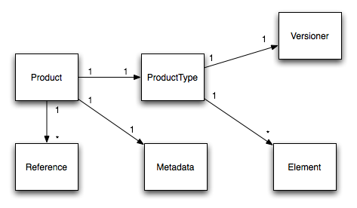
Figure 1. File Manager Object Model

- Architecture

The File Manager component is responsible for tracking, ingesting and moving file data and metadata between a client system and a server system. The File Manager is an extensible software component that provides an XML-RPC external interface, and a fully tailorable Java-based API for file management. The critical objects managed by the File Manager include:

- Products - Collections of one or more files, and their associated Metadata.
- Metadata - A map of key->multiple values of descriptive information about a Product.
- Reference - A pointer to a Product file's original location, and to its final resting location within the archive constructed by the File Manager.
- Product Type - Descriptive information about a Product that includes what type of file URI generation scheme to use, the root repository location for a particular Product, and a description of the Product.
- Element - A singular Metadata element, such as "Author", or "Creator". Elements may have additional metadata, in the form of the associated definition and even a corresponding Dublin Core attribute.
- Versioner - A URI generation scheme for Product Types that defines the location within the archive (built by the File Manager) where a file belonging to a Product (that belongs to the associated Product Type) should be placed.

Each Product contains 1 or more References, and one Metadata object. Each Product is a member of a single Product Type. The Metadata collected for each Product is defined by a mapping of Product Type->1...* Elements. Each Product Type has an associated Versioner. These relationships are shown in Figure 1.

  - Extension Points

There are several extension points for the File Manager. An extension point is an interface within the file manager that can have many implementations. This is particularly useful when it comes to software component configuration because it allows different implementations of an existing interface to be selected at deployment time. So, the File Manager component may communicate with a Database-based Catalog, and an XML-based Element Store (called a Validation Layer), or it may use a Lucene-based Catalog and a Database-based Validation Layer. The selection of the actual component implementations is handled entirely by the extension point mechanism. Using extension points, it is fairly simple to support many different types of what are typically referred to as “plug-in architectures” Each of the core extension points for the File Manager is described below:

- Catalog - The Catalog extension point is responsible for storing all the instance data for Products, Metadata, and for file References. Additionally, the Catalog provides a query capability for Products.
- Data Transfer - The Data Transfer extension point allows for the movement of a Product to and from the archive managed by the File Manager component. Different protocols for Data Transfer may include local (disk-based) copy, or remote XML-RPC based transfer across networked machines.
- Repository Manager - The Repository Manager extension point provides a means for managing all of the policy information (i.e., the Product Types and their associated information) for Products managed by the File Manager.
- Validation Layer - The Validation Layer extension point allows for the querying of element definitions associated with a particular Product Type. The extension point also maps Product Type to Elements.
- Versioning - The Versioning extension point allows for the definition of different URI generation schemes that define the final resting location of files for a particular Product.
- System - The extension point that provides the external interface to the File Manager services. This includes the File Manager server interface, as well as the associated File Manager client interface, that communicates with the server.

The relationships between the extension points for the File Manager are shown in Figure 2.
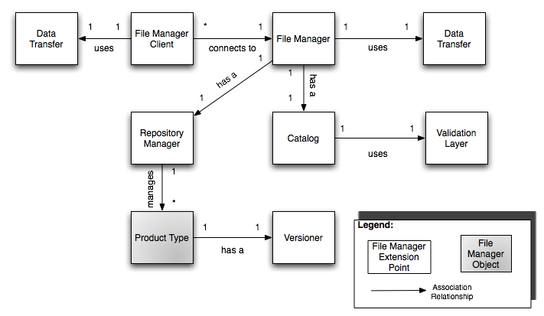
Figure 2. File Manager Extension Point Relationships

  - Key Capabilities

The File Manager is responsible for providing the necessary key capabilities for managing files and metadata. Each high level capability provided by the File Manager is detailed below:

- Easy Management of different types of Products – The Repository Manager extension point is responsible for managing Product Types, and their associated information. Management of Product Types includes adding new ones, deleting and updating existing ones, and retrieving Product Types, by their ID or by their name.
- Support for different kinds of back end catalogs – The Catalog extension point allows Product instance metadata and file location information to be stored in different types of back end data stores quite easily. Existing implementations of the Catalog interface include a JDBC based backend database, along with a flat-file based, Lucene index.
- Management of Product instance information – The management includes adding, deleting and updating product instance information, including file locations (References), along with Product Metadata. It also includes getting Metadata, and getting References associated with existing Products. It also includes obtaining the Products themselves.
- Separating out the Element management layer for Metadata – The File Manager Validation Layer extension points allows for the management of Element policy information in different types of back end stores. For instance, Element policy could be stored in XML files, a Database, or even a Metadata Registry.
- Supporting different Data Transfer Mechanisms – By having an extension point for Data Transfer, the File Manager can support different Data Transfer protocols, both local and remote.
- Allowing for different Back End File Repository Layouts – The Versioner extension points allows for different File Repository Layouts based on Product Types.
- Allowing for Hierarchical collections of files and directories making up a Product – The File Manager Client allows for Products to be Flat, or Hierarchical-based. Flat products are collections of singular files that are aggregated together to make a Product. Hierarchical Products are Products that contain collections of directories, and sub-directories, and files.
- Scalability – The File Manager uses the popular client-server paradigm, allowing new File Manager servers to be instantiated, as needed, without affecting the File Manager clients, and vice-versa.
- Communication over lightweight, standard protocols – The File Manager uses XML-RPC, as its main external interface, between File Manager client and server. XML-RPC, the little brother of SOAP, is fast, extensible, and uses the underlying HTTP protocol for data transfer.
- RSS based Product Syndication – The File Manager web interface allows for the RSS-based syndication of Product feeds based on Product Type.
- Data Transfer Status Tracking – The File Manager tracks all current Product and File transfers and even publishes an RSS-feed of existing transfers.

This capability set is not exhaustive, and is meant to give the user a “feel” for what general features are provided by the File Manager. Most likely the user will find that the File Manager provides many other capabilities besides those described here.

  - Current Extension Point Implementations

There are at least two implementations of all of the aforementioned extension points for the File Manager. Each extension point implementation is detailed below:

Catalog

- Data Source based Catalog – an implementation of the Catalog extension point interface that uses a JDBC accessible database backend.
- Lucene based Catalog – an implementation of the Catalog extension point interface that uses the Lucene free text index system to store Product instance information.

Data Transfer

- Local Data Transfer – an implementation of the Data Transfer interface that uses Apache’s commons-io to perform local, disk based filesystem data transfer. This implementation also supports locally accessible Network File System (NFS) disks.
- Remote Data Transfer – an implementation of the Data Transfer interface that uses the XML-RPC File Manager client to transfer files to a remote XML-RPC File Manager server.

Repository Manager

- Data Source based Repository Manager – an implementation of the Repository Manager extension point that stores Product Type policy information in a JDBC accessible database.
- XML based Repository Manager – an implementation of the Repository Manager extension point that stores Product Type policy information in an XML file called “product-types.xml”

Validation Layer

- Data Source based Validation Layer – an implementation of the Validation Layer extension point that stores Element policy information in a JDBC accessible database.
- XML based Validation Layer – an implementation of the Validation Layer extension point that stores Element policy information in 2 XML files called “elements.xml” and “product-type-element-map.xml”

System (File Manager client and File Manager server)

- XML-RPC based File Manager server – an implementation of the external server interface for the File Manager that uses XML-RPC as the transportation medium.
- XML-RPC based File Manager client – an implementation of the client interface for the XML-RPC File Manager server that uses XML-RPC as the transportation medium.

- Configuration and Installation

To install the File Manager, you need to check out the cas-filemgr project from the OODT subversion repository. You can browse the repository using ViewCVS, located at:

http://oodt.jpl.nasa.gov/vc/svn/

To check out the File Manager, use your favorite Subversion client. Several clients are listed at:

http://oodt.jpl.nasa.gov/wiki/display/oodt/Subversion

Once you have the File Manager checked out, you'll also need to check out the cas-metadata project. cas-metadata provides the multi-valued Metadata container class that is shared by both the File Manager and the Workflow Manager CAS components. Check out cas-metadata in the same fashion that you checked out the cas-filemgr project.

  - Project Organization

The cas-filemgr project follows the traditional Subversion-style "trunk", "tag" and "branches" format. Trunk corresponds to the latest and greatest development on the cas-filemgr. Tags are official release versions of the project. Branches correspond to deviations from the trunk large enough to warrant a separate development tree.

For the purposes of this the User Guide, we'll assume you're building cas-filemgr from the trunk, though if you were building a tagged release (or branch) the process would be quite similar.

To build cas-filemgr, and cas-metadata, you'll need the Apache Maven software. Maven is an XML-based, project management system similar to Apache Ant, but with many extra bells and whistles. Maven makes cross-platform project development a snap. You can download Maven from:

http://maven.apache.org.

The cas-filemgr is constructed to be compatible with the 1.x.x series of Maven, despite Maven 2.x having already been released. Once you have Maven installed, follow the procedure in Section 4.2 to build a fresh copy of the File Manager:

  - Building the File Manager

1. cd to cas-metadata, and then type:

# maven jar:install

This will construct the cas-metadata jar file, and then install it into your local Maven repository. You'll need cas-metadata when building cas-filemgr.

2. cd to cas-filemgr, and then type:

# maven dist:build-bin

This will perform several tasks, including compiling the source code, downloading required jar files, running unit tests, and so on. When the command completes, cd to the "target/distributions" directory within cas-filemgr. This will contain the build of the File Manager component. The directory layout is as follows:

bin/ etc/ logs/ lib/ policy/ LICENSE.txt

- bin - contains the "filemgr" server script, and the "filemgr-client" client script.
- etc - contains the logging.properties file for the File Manager, and the filemgr.properties file used to configure the server options
- logs - the default directory for log files to be written to
- lib - the required Java jar files to run the File Manager
- policy – the default XML-based element and product type policy in case the user is using the XML Repository Manager and/or the XML Validation Layer.
- LICENSE.txt - the LICENSE for the File Manager project.

  - Deploying the File Manager

To deploy the file manager, you'll need to create an installation directory. Typically this would be somewhere in /usr/local (on *nix style systems), or C:\Program Files\ (on windows style systems). We'll assume that you're installing on a *nix style system though the Windows instructions are quite similar.

Follow the process below to deploy the File Manager:

- Make the deployment directory

# mkdir /usr/local/filemgr

- Copy the binary distribution to the deployment directory

# cp -R cas-filemgr/trunk/target/distributions/* /usr/local/filemgr/

- Edit /usr/local/filemgr/bin/filemgr
  - Set the SERVER_PORT variable to the desired port you'd like to run the File Manager server on.
  - Set the JAVA_HOME variable to point to the location of your installed JRE runtime.
  - Set the RUN_HOME variable to point to the location you'd like the File Manager PID file written to. Typically this should default to "/var/run", but not all system administrators allow users to write to /var/run.
- edit /usr/local/filemgr/bin/filemgr-client
  - Set the JAVA_HOME variable to point to the location of your installed JRE runtime.
- (optional) edit /usr/local/filemgr/etc/logging.properties
  - Set the logging levels for each subsystem to the desired level. The system defaults are fairly considerate and prevent much of the logging at levels below INFO to the console.
- edit /usr/local/filemgr/etc/filemgr.properties
  - This java properties file contains all of the default information properties to configure the File Manager. By default, the File Manager is built to use the XML-based repository manager and validation layer extension points, the DataSource based catalog extension point, and the local data transfer interface. These defaults can be changed quite easily by changing the factory classes that are pointed to for each extension point. For example, to use the Lucene-based cataog extension point, you would change the following property:

filemgr.catalog.factory

to

gov.nasa.jpl.oodt.cas.filemgr.catalog.LuceneCatalogFactory

  - You need to configure the properties for each of the extension points that you are using. By default, you would at least need to configure:
    - The JDBC connection information for the data source catalog.
    - The paths to the directories where the XML policy files are stored for the validation layer and for the repository manager. A good default location is to place these files within /usr/local/filemgr/policy.

Other configuration options are possible: check the API documentation, as well as the comments within the filemgr.properties file to find out the rest of the configurable properties for the extension points you choose. A full listing of all the extension point factory class names are provided in the Appendix. After step 7, you are officially done configuring the File Manager for deployment.

  - Running the File Manager

To run the filemgr, cd to /usr/local/filemgr/bin and type:

# ./filemgr start

This will startup the file manager XML-RPC server interface. Your File Manager is now ready to run! You can test out the file manager by running a simple ingest command using the filemgr-client command below. First create a simple text file called "blah.txt" and place it inside /usr/local/filemgr/bin. Then, create a blank metadata file for the product, using the schema or DTD provided in the cas-metadata project. An example XML file might be:

<cas:metadata xmlns:cas="http://oodt.jpl.nasa.gov/1.0/cas">
</cas:metadata>

Call this metadata file blah.txt.met, and place it also in /usr/local/filemgr/bin. Then, run the below command, assuming that you started the File Manager on the default port of 9000:

# ./filemgr-client --url http://localhost:9000 --operation --ingestProduct --productName Blah.txt
--productStructure Flat --productTypeName GenericFile --metadataFile file:/usr/local/filemgr/bin/blah.txt.met
--clientTransfer --dataTransfer gov.nasa.jpl.oodt.cas.filemgr.datatransfer.LocalDataTransferFactory
--refs file:/usr/local/filemgr/bin/blah.txt

You should see a response message at the end similar to:

Jul 15, 2006 10:37:53 PM gov.nasa.jpl.oodt.cas.filemgr.system.XmlRpcFileManagerClient <init>
INFO: Loading File Manager Configuration Properties from: [../etc/filemgr.properties]
Jul 15, 2006 10:37:54 PM gov.nasa.jpl.oodt.cas.filemgr.system.XmlRpcFileManagerClient ingestProduct
FINEST: File Manager Client: clientTransfer enabled: transfering product [Blah.txt]
Jul 15, 2006 10:37:54 PM gov.nasa.jpl.oodt.cas.filemgr.versioning.VersioningUtils createBasicDataStoreRefsFlat
FINE: VersioningUtils: Generated data store ref: file:/tmp/files/Blah.txt/blah.txt from origRef: file:/usr/local/filemgr/bin/blah.txt
Jul 15, 2006 10:37:54 PM gov.nasa.jpl.oodt.cas.filemgr.datatransfer.LocalDataTransferer moveFilesToProductRepo
INFO: LocalDataTransfer: Moving File: file:/usr/local/filemgr/bin/blah.txt to file:/tmp/files/Blah.txt/blah.txt
ingestProduct: Result: 3a812d86-148d-11db-a25a-f388f524a371

which means that everything installed okay!

- Use Cases

The File Manager was built to support several of the above capabilities outlined in Section 3. In particular there were several use cases that we wanted to support, some of which are described below.

  - File Ingestion and Metadata and File Location Tracking

The File Manager should be able to perform “file ingestion” which typically means the cataloging of a file’s associated metadata, and file locations, along with the physical transferring of a file from a user’s machine to an archive machine that is managed by the File Manager. XXX is a graphical depiction of that use case.

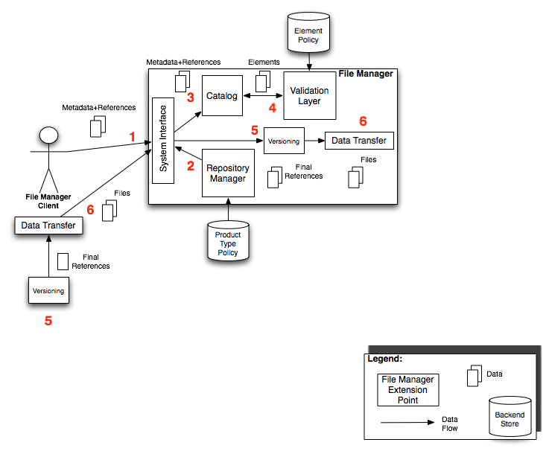
Figure 3. Supporting the File Ingestion Use Case

The red numbers in Figure 3 correspond to a sequence of steps that occurs and a series of interactions between the different File Manager extension points in order to perform the file ingestion activity. In Step 1, a File Manager client is invoked for the ingest operation, which sends Metadata and References for a particular Product to ingest to the File Manager server’s System Interface extension point. The System Interface uses the information about Product Type policy made available by the Repository Manager in order to understand whether or not the product should be transferred, where it’s root repository path should be, and so on. The System Interface then catalogs the file References and Metadata using the Catalog extension point. During this catalog process, the Catalog extension point uses the Validation Layer to determine which Elements should be extracted for the particular Product, based upon its Product Type. After that, Data Transfer is initiated either at the client or server end, and the first step to Data Transfer is using the Product’s associated Versioner to generate final file References. After final file References have been determined, the file data is transferred by the server or by the client, using the Data Transfer extension point.

- Appendix

Full list of File Manager extension point classes and their associated property names from the filemgr.properties file:

Property Name | Classes
filemgr.catalog.factory | gov.nasa.jpl.oodt.cas.filemgr.catalog.DataSourceCatalogFactory  gov.nasa.jpl.oodt.cas.filemgr.catalog.LuceneCatalogFactory
filemgr.repository.factory | gov.nasa.jpl.oodt.cas.filemgr.repository.DataSourceRepositoryManagerFactory  gov.nasa.jpl.oodt.cas.filemgr.repository.XMLRepositoryManagerFactory
filemgr.datatransfer.factory | gov.nasa.jpl.oodt.cas.filemgr.datatransfer.LocalDataTransferFactory  gov.nasa.jpl.oodt.cas.filemgr.datatransfer.RemoteDataTransferFactory
filemgr.validationLayer.factory | gov.nasa.jpl.oodt.cas.filemgr.validation.DataSourceValidationLayerFactory  gov.nassa.jpl.oodt.cas.filemgr.validation.XMLValidationLayerFactory

Lucene is a free text indexing API and engine freely available from the Apache Software Foundation

